Community Venue Planned for Alty

Altrincham FC has announced plans to build a community hall at Moss Lane in a bid to inspire local people to get involved in sport.

The venue will provide a home for local sports clubs and leisure groups including indoor bowls, martial arts, cricket, pilates and dance.

Chairman Grahame Rowley said: “We were all inspired by London 2012 and as a club, we want to play a leading role in helping Altrincham people play sport – not just football!

“It’s coming up to a year since the Games and we’ve been working hard to get this project off the ground. I’m delighted we’re now in a position to submit to planning and we’re hoping local people and businesses really get behind it.“

The new low-rise facility will significantly improve what is currently a run-down section of the ground. The development includes improvements to the car park on Golf Road to make sure all traffic is accommodated for.

The venue will house a bar for club use on match-days and also feature a museum to celebrate Alty’s famous giant-killing FA Cup exploits. The museum will also detail the town’s rich and colourful history.

Altrincham FC recently established a non-profit trust, and as a result, the club can access funding from the Premier League and other organisations. The development is expected to cost up to £750,000, with the club looking to raise around £200,000 from a series of fund-raising activities and sponsorship support from local businesses.

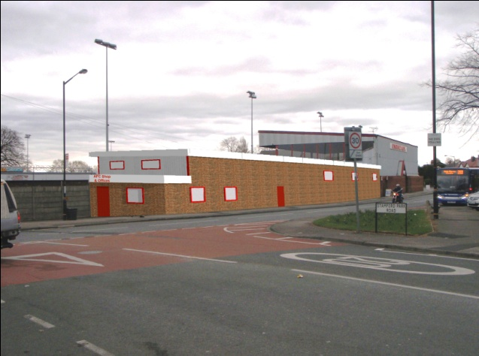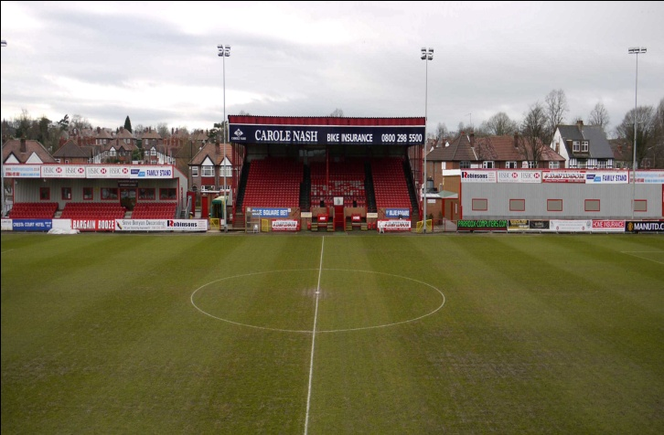
How Moss Lane will look after construction

To help launch the Community Hall project, the club is planning a summer sport festival event to be held at Moss Lane. More details will be announced in due course.

Notes:

- Altrincham FC has been based at Moss Lane for more than a century
- The club runs a variety of community programmes and supports 37 junior football teams
- The Community Sports Hall will be used by young people, the elderly, and disabled groups
- The hall will be suitable for many sports including minority sports
- The hall will be available for local sports clubs and schools
- The hall will provide a facility for seminars, workshops, and local health/wellbeing groups
- The hall will be used by the club on Match-days
- The Sport Business CIC has been taken on by Altrincham FC to oversee fundraising and communications for the proposed development
- The Sport Business is a Sale-based social enterprise (www.thesportbusiness.co.uk)
- For more details contact Dominic McGuinness: 0161 969 2242 / 07968 326541

